Championship Show Welsh Cardigan Club Nederland

Sunday the 22nd of October 2017 at Heteren

Judge: Miss Eileen Eby (UK)

Entry form

Breed: Welsh Corgi Cardigan Sex:_________________________________________________

Name of the dog ___________________________________________________________________________

Titles _____________________________________________________________________________________

Pedigree No. ______________________ Date of birth ____________________________ ________________

Class__________________

1. Baby class (3-6 months)*

2. Puppy class (6-9 months)*

3. Junior class (9-18 months)

5. Open class (as from 15 months)

6. Champion class**

7. Veteran class (as from 8 years)

4. Intermediate class (15-24 months) 8. Breeders class (as from 9 months)

* cannot get a CAC
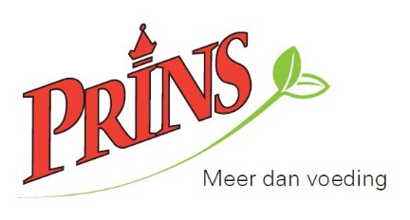
**copy of statement of the ruling organization or copy championship must be included. If not enclosed the dog will be entered in the Open class.

Hoofdsponsor

Breeder ____________________________________________________________________________________

Sire ________________________________________________________________________________________

Dame _______________________________________________________________________________________

Owner First name(s)_______________ _ Family name ______________________________

Co-owner First name(s) _______________ Family name ______________________________

Address ________________________________________________________________ No. _________________

Code and city _______________________________________________________________________________

Tel.__________________________ E-mail _____________________________________________________

Forwarding address (only to be filled in in case of a different address)***

Address _________________________________________ Code and city _____________________________

***In case of a forwarding address the person living there is co-responsible for the entry fee.

Entry forms to be sent to:
A. Jonkers
Beverodelaan 61
6952 JC Dieren
kcm@wccn.nl

Payment
Welsh Cardigan Club Nederland
IBAN: NL82INGB0002703680
BIC: INGBNL2A
stating Championship show 2017
and pedigree number.

Application fee
1st dog € 30,00
2nd dog etc. € 25,00 (the same owner)
Baby class/Puppy class € 15,00

Entry fee for……..dogs €
Sponsoring Show €
Price donation €
(the appl. fee must be paid at the same time the entry
form is sent and is only confirmed if the appl. fee is
paid for).

The show regulations, the rules of the Dutch Kennel Club and the FCI are in force. These Closing entry date
rules are to be considered as part of this entry. By sending in this form you state to know
and accept these rules. Sending in the form is considered the same as your sign. 07-10-2017

Date…………………………. Signature…………………………………………………….

